System Requirements Statement (SRS) –

Home Rental

1. Introduction 3

2. Functional Requirements 4

2.1 Tenant Module 5

2.2 Owner Module 9

2.3 admin Module 12

2.4 UseCaseDiagram..................................................................................................................................13

1. **Introduction**

This document explains the system requirements and scope for developing Home Rental.

Home Rental could divide the three main modules->Tenant part,Property Owner part, Admin part.

1. **Functional Requirements**

The Account part of Home Rental has three modules which are divided 13 processes described as below.

|  |  |  |
| --- | --- | --- |
| **No** | **BRS requirement ID** | **Description** |
| **2.1** | **Tenant Module** | |
| **2.1.1** | **F1** | **Register Process(Fees)** |
| **2.1.2** | **F2** | **Login Process** |
| **2.1.3** | **F3** | **Forgot Password Process** |
| **2.1.4** | **F4** | **Change Password Process** |
| **2.1.5** | **F5** | **Update Profile** |
| **2.1.6** | **F6** | **Search Property** |
| **2.1.7** | **F7** | **Add To WishList** |
| **2.1.8** | **F8** | **Request For Owner Info** |
| **2.1.9** | **F9** | **Feedback and Rating** |
| **2.2** | **Owner Module** | |
| **2.2.1** | **F10** | **Register(free creation)** |
| **2.2.2** | **F11** | **Login Process** |
| **2.2.3** | **F12** | **Forgot Password Process** |
| **2.2.4** | **F13** | **Change Password Process** |
| **2.2.5** | **F14** | **Update Account Process** |
| **2.2.6** | **F15** | **Add Property (Fees)** |
| **2.2.7** | **F16** | **Modify Property** |
| **2.2.8** | **F17** | **Request To Remove Property** |
| **2.2.9** | **F18** | **Browse Other Properties** |
| **2.3 Admin Module** | | |
| **2.3.1** | **F19** | **Login Process** |
| **2.3.2** | **F20** | **Forgot Password Process** |
| **2.3.3** | **F21** | **Change Password Process** |
| **2.3.4** | **F22** | **Update Account Process** |
| **2.3.5** | **F23** | **Approve Property** |
| **2.3.6** | **F24** | **Manage Transaction(Report)** |

* 1. **Tenant Module**
* Tenants are the user of system who wants to rent a property.
* They are able to view and search the properties.
  + 1. **Register Process**
* Home Rental compels to login before viewing owner information. So, Home Rental should provide the function which makes tenant to create new account.
* When tenant creates new account, the function demands following information described as below.

1. UserID
2. Password
3. First Name
4. Last Name
5. E-mail address
6. Address
7. Phone No
8. Payment
   * All items are compulsory demanded.
9. UserID

* The UserID should be unique. If the UserID corresponds with not case-sensitive to other which is previously registered, the UserID should not be registered as an account.

1. Password

* The Password has a constraints which makes the Password consists of more than or equal 8 and less than or equal 16 characteristics including characters described as below.
* Numeric figure (at least one)
* Capital alphabet (A-Z)(at least one)
* Small alphabet (a-z)(at least one)
* Special character (#, $, %, &, etc.) (at least one)
* The Password is masked by dummy characters. The re-entering Password is demanded.

1. First name

* First name has the constraints which contain max size of 15 characters.

1. Last name

* First name has the constraints which contain max size of 15 characters.

1. Email Address

* Email address should be valid

1. Address

* Address has the constraints which contain max size of 200 characters.

1. Phone no

* Phone number has the constraints which contain exactly 10 digit.
  + 1. **Login Process**
* The user authentication demands UserID and Password. The UserID and the Password should be checked as below.
  + The UserID and the Password should be existed and correct.
* If The UserID and the Password are not equal to what the user has registered, the user authentication cannot be provided.
* The “Home Page” provides the some items described as below.

1. A trigger to logout
2. A trigger to profile
3. A trigger to Search Properties
4. A trigger to wishlist
5. //A trigger to new arrivals and Suggestions
   * 1. **Forgot Password Process**

* When system user lost their Password, the recovery method should be provided by Home Rental.

The recovery method is described as below.

* + First, system user enters their UserID for Home Rental.
  + Next, Home Rental demands email id , which has been registered since when the Account was created.
  + Tenants get the new password by E-mail.
  + The password is changed to new password automatically by Home Rental.
* Of course, the new password should consist of more than or equal 8 and less than or equal 16 characteristics.
* As a consequence, The Tenant can re-login using the new password.
  + 1. **Change Password Process**
* When Tenant wants to change their Password, the measure should be provided by Home rental .
* Therefore, Home Rental should provide this function which is available after the Tenant logs in.
* The function demands the current password and the new password.
  + The new password should consist of more than or equal 8 and less than or equal 16 characteristics including at least a numeric figure, a capital alphabet, a small alphabet, and a special character.
  + The current password and the new password are masked by using dummy characters.
  + The new password is demanded to enter twice to avoid a typing error.
* Only when the current password is correct, Tenant could change their Password.
  + 1. **Update Profile**
* Home Rental should provide the function which makes the account updated for Tenant.
* The information Tenant could update is described below.

1. Login information
2. User information

* The Login information

The updatable items as described below.

1. UserId
2. Password
   * All items are compulsory demanded, but updating is optional.

* The User information

The updatable items as described below

1. First Name
2. Last Name
3. Phone No
4. E-mail address
5. address
   * All items are compulsory demanded, but updating is optional.
     1. **Search Property**

* Search conditions are described as below.

1. Price Range
2. Location
   * 1. **Add To WishList**

* After selecting property, tenant can add that property to the wishlist for future references.
* At time of adding to wish list tenant login is required.
  + 1. **Request For Owner Info**
* Tenant can demand information about the property owner(restricted number of requests to owners info is given after registration).
  + 1. **Feedback and Rating**
* Tenant can give feedback and rating .
  1. **Owner Module**
     1. **Register Process**
* Home Rental compels to login before adding a property So, Home Rental should provide the function which makes owners to create new account.
* When owner creates new account, the function demands following information described as below.

1. UserID
2. Password
3. First Name
4. Last Name
5. E-mail address
6. Address
7. Phone No
8. //Payment
   * All items are compulsory demanded.
9. UserID

* The UserID should be unique. If the UserID corresponds with not case-sensitive to other which is previously registered, the UserID should not be registered as an account.

1. Password

* The Password has a constraints which makes the Password consists of more than or equal 8 and less than or equal 16 characteristics including characters described as below.
* Numeric figure (at least one)
* Capital alphabet (A-Z)(at least one)
* Small alphabet (a-z)(at least one)
* Special character (#, $, %, &, etc.) (at least one)
* The Password is masked by dummy characters. The re-entering Password is demanded.

1. First name

* First name has the constraints which contain max size of 15 characters.

1. Last name

* First name has the constraints which contain max size of 15 characters.

1. Email Address

* Email address should be valid

1. Address

* Address has the constraints which contain max size of 200 characters.

1. Phone no

* Phone number has the constraints which contain exactly 10 digit.
  + 1. **Login Process**
* Home Rental always compels owner authentication before using itself.
* The user authentication demands UserID and Password. The UserID and the Password should be checked as below.
  + The UserID and the Password should be existed and correct.
* If The UserID and the Password are not equal to what the user has registered, the user authentication cannot be provided.
* The “Home Page” provides the some items described as below.

1. A trigger to logout
2. A trigger to profile
3. A trigger to add the property
4. A trigger to remove the property
5. A trigger to modify the property
6. A trigger to search properties
   * 1. **Forgot Password Process**

* When system user lost their Password, the recovery method should be provided by Home Rental.

The recovery method is described as below.

* + First, system user enters their UserID for Home Rental.
  + Next, Home Rental demands email id , which has been registered since when the Account was created.
  + Owners get the new password by E-mail.
  + The password is changed to new password automatically by Home Rental.
* Of course, the new password should consist of more than or equal 8 and less than or equal 16 characteristics.
* As a consequence, The Owner can re-login using the new password.
  + 1. **Change Password Process**
* When Owner wants to change their Password, the measure should be provided by Home Rental.
* Therefore, Home Rental should provide the function which is available after the Owners logs in.
* The function demands the current password and the new password.
  + The new password should consist of more than or equal 8 and less than or equal 16 characteristics including at least a numeric figure, a capital alphabet, a small alphabet, and a special character.
  + The current password and the new password are masked by using dummy characters.
  + The new password is demanded to enter twice to avoid a typing error.
* Only when the current password is correct, Owner could change their Password.
  + 1. **Update Account Process**
* Home Rental should provide the function which makes the account updated for Owner.
* The following information can be updated by the owner .

1. Login information
2. User information
   * All items are compulsory demanded, but updating is optional.

* The Login information

The updatable items as described below.

1. Password

* The User information

The updatable items as described below.

1. First Name
2. Last Name
3. Phone No
4. E-mail address
5. Address
   * 1. **Add Property**

Home Rental Provides a feature by using which owner can add new property .

* Name of Property
* Location
* Date
* Duration
* Capacity
* Last date of booking
* Description
  + 1. **Modify Property**

Home Rental Provides a feature by using which owner can add/modify property .

* + Date
  + Duration
  + Tenant capacity
* Description
  + 1. **Request To Remove Property**
* Home Rental provide feature which is used by owner to remove property if required.
* Admin will get the required information for documentation from owner.
  + 1. **Browse Other Properties**
* Owner can browse other properties.
  1. **Admin Module**
     1. **Login Process**
* The admin authentication demands userID and Password. The UserID and the Password should be checked as below.
  + The UserID and the Password should be existed and correct.
* The “Home Page” provides the some items described as below.

1. A trigger to logout
2. A trigger to profile
3. A trigger to search property
4. A trigger to approve Property
5. A trigger to manage transaction
6. A trigger to approve/manage user accounts
   * 1. **Forgot Password Process**

* When admin lost their Password, the recovery method should be provided by Home Rental.

The recovery method is described as below.

* + First, system user enters their UserID for Home Rental.
  + Next, Home Rental demands email id , which has been registered since when the Account was created.
  + Admin get the new password by E-mail.
  + The password is changed to new password automatically by Home Rental.
* Of course, the new password should consist of more than or equal 8 and less than or equal 16 characteristics.
* As a consequence, The Admin can re-login using the new password.
  + 1. **Change Password Process**
* When Admin wants to change their Password, the measure should be provided by Home Rental.
* Therefore, Home Rental should provide the function which is available after the Admins logs in.
* The function demands the current password and the new password.
  + The new password should consist of more than or equal 8 and less than or equal 16 characteristics including at least a numeric figure, a capital alphabet, a small alphabet, and a special character.
  + The current password and the new password are masked by using dummy characters.
  + The new password is demanded to enter twice to avoid a typing error.
* Only when the current password is correct, Admin could change their Password.
  + 1. **Update Account Process**
* Home Rental should provide the function which makes the account updated for Admin.
* The following information can be updated by the Admin .
  + All items are compulsory demanded, but updating is optional.

1. Name
2. Password
3. E-mail address
   * 1. **Approve Property**

* Home Rental provides a feature when owner add a new property, request will receive to admin portal for approval.
  + 1. **Manage Transaction(Report)**
* Admin can manage all the transactions made by tenants and owners.
* Admin can also make report based on revenue generated by subscriptions of tenants and owners.
  1. **Use Case Diagram**
     1. **Admin :**

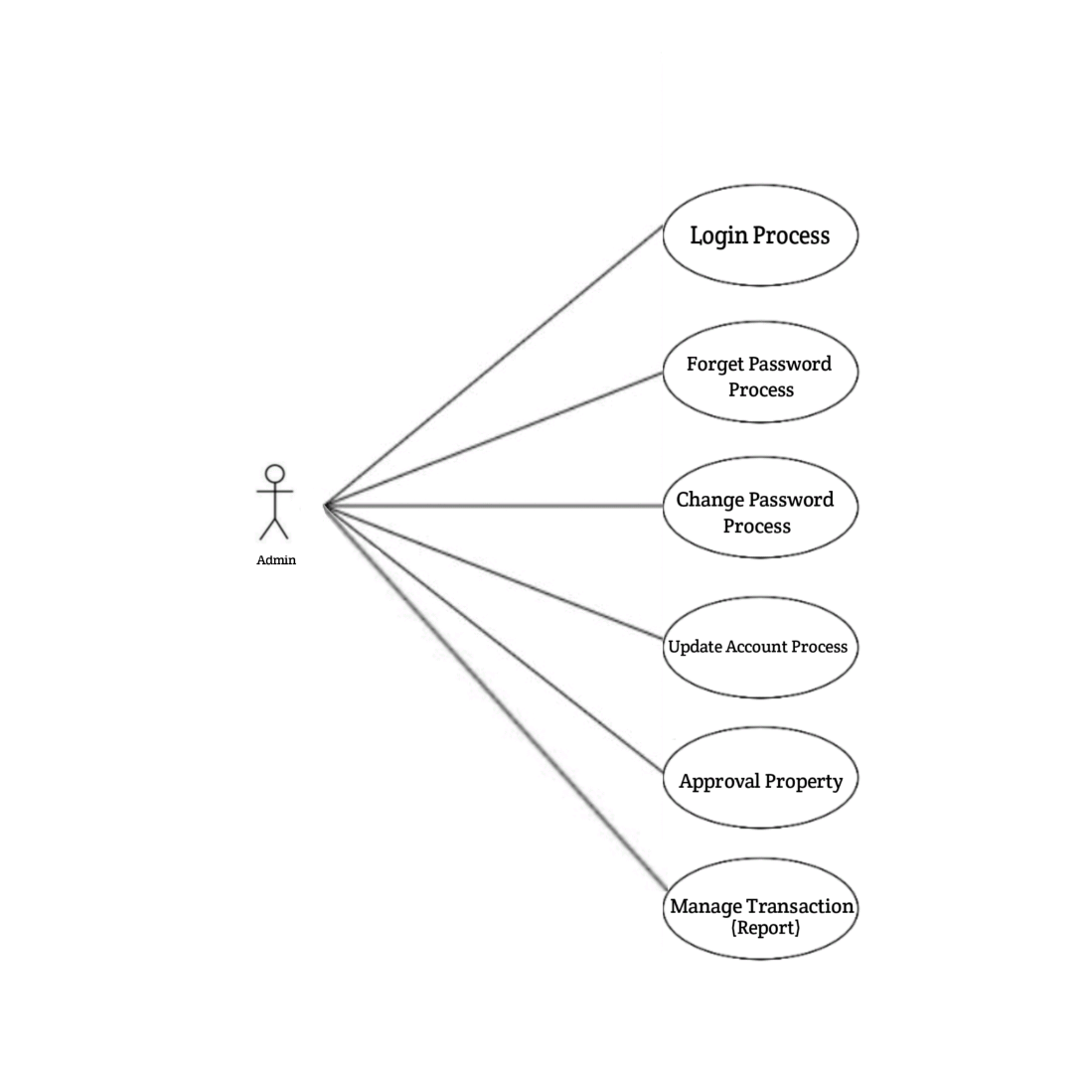

*Fig. Use case diagram for admin*

1. In Admin use case diagram Admin is the Actor.
2. Admin can handle following use cases:
3. Login
4. Forgot Password
5. Change Password
6. Update Profile
7. Approve Property
8. Manage transactions(Report)
   * 1. **Tenant :**

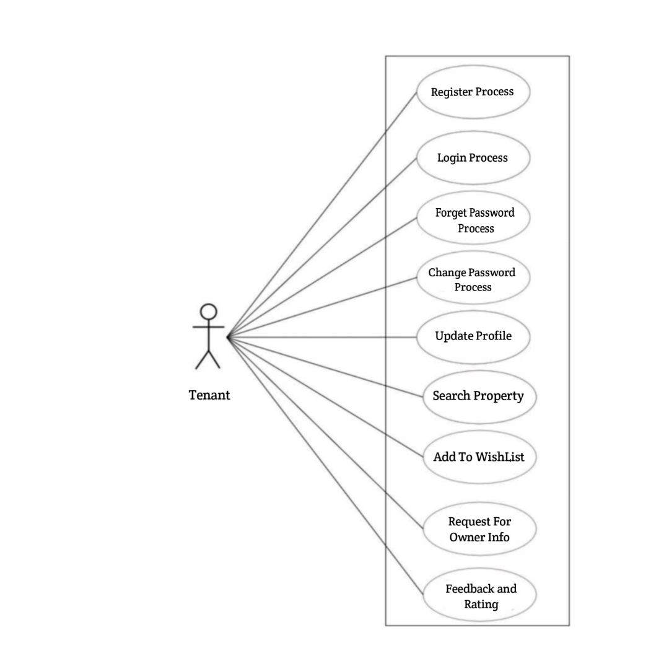

*Fig. Use case diagram for Tenant*

1. In Tenant use case diagram Tenant is the Actor.
2. Tenant can handle following use cases:
3. Register
4. Login
5. Forgot Password
6. Change Password
7. Update Profile
8. Search Property
9. Add to wishlist
10. Request for Owner Info
11. Feedback and Rating
    * 1. **Owner :**

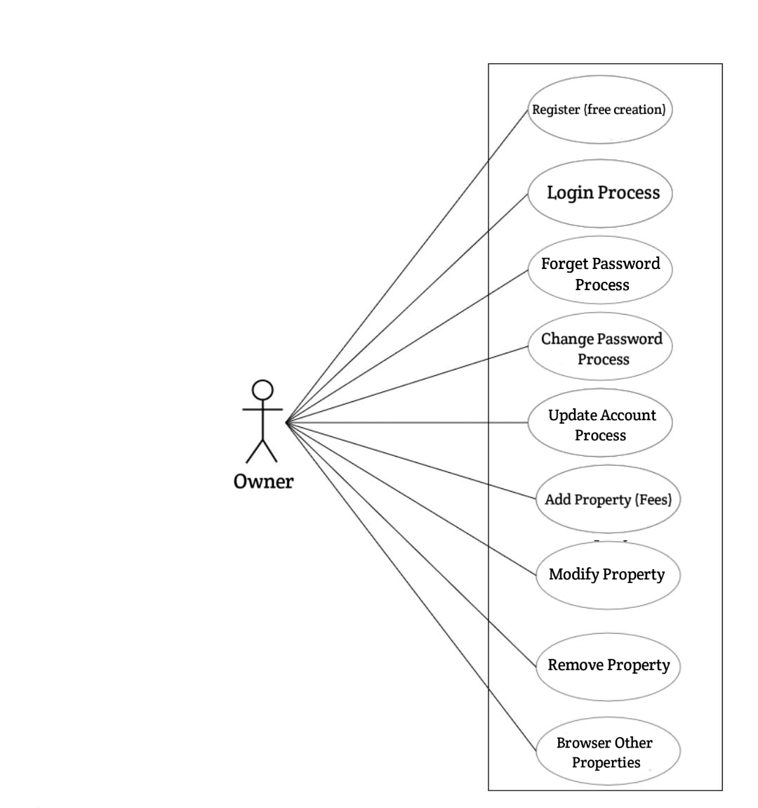

*Fig. Use case diagram for Owner*

1. In Owner use case diagram Owner is the Actor**.**
2. Owner can handle following use cases:
3. Register
4. Login
5. Forgot Password
6. Change Password
7. Update Account
8. Add Property
9. Modify Property
10. Request to Remove Property
11. Browse other Properties